**CHAPTER 1**

**INTRODUCTION**

The number of vehicles on the road are increasing day by day so it is important to manage the traffic flow efficiently in order to utilize the existing road capacity in the best way possible. Developing a smart traffic management system to optimize traffic flow, reduce congestion, while minimizing the travel time and maximizing mobility. Installation of traffic signals can actually cause a deterioration in overall safety of intersections. Time traffic signals can cause a situation of deadlock. Metro cities and many majorly populated cities have traffic signals at very short distances which prevent the smooth flow of traffic. Severe traffic can cause phantom traffic jams. The present automated traffic control systems work on time-based algorithms. Each lane is allotted a fixed time for traffic to clear off, the times may be equal for all lanes or based on the average vehicle density.

***1.1 LITERATURE REVIEW***

* Traffic congestion is a pressing urban issue with negative economic, environmental, and societal impacts. This literature review aims to explore and evaluate diverse strategies to address traffic congestion.
* Causes and Effects: Traffic congestion stems from factors like population growth, limited road capacity, and car dependency.
* Traffic lights play a pivotal role in managing intersections and regulating traffic. They facilitate the orderly movement of vehicles, pedestrians, and cyclists by assigning right-of-way and controlling signal timing.
* Numerous cities have adopted adaptive signal control systems and coordinated signal timing strategies. Successful implementations have demonstrated reduced travel times, enhanced traffic flow, and minimized congestion.
* Benefits and Challenges: Benefits of traffic light solutions include improved traffic flow, reduced congestion, and potential fuel savings. However, challenges include initial implementation costs, maintenance, and potential disruptions during deployment.
* In our project, we have to select at least a 5MP day and night IP camera for capturing real-time traffic data at key traffic junctions. The choice of camera is a critical component as it directly affects the accuracy and efficiency of our traffic management system
* The efficiency of our traffic management system also depends on the computer system used for data processing and control logic execution. We need at least a Intel Celeron or AMD A9 Based processer with good network connectivity. The selected computer system should meet or exceed these specifications to ensure smooth video processing, real-time traffic analysis, and adaptive signal control.

***1.2 MOTIVATION***

The motivation behind embarking on this project is multi-faceted, stemming from both personal and societal aspirations. As technology continues to shape our world, it becomes imperative to leverage its power to address pressing urban challenges like traffic problems. Here are some key reasons driving our enthusiasm for this project

* Exploration of AI and Applied Machine Learning: We're eager to delve into the world of AI and Machine Learning, particularly in computer vision and object detection, to address urban challenges like traffic issues.
* Real-world Application of Technical Skills: We aim to apply our theoretical knowledge in practical ways, using AI-based traffic management to make a meaningful impact on the lives of city residents.

***1.3 PROBLEM DEFINITION***

Developing a smart traffic management system using AI to optimize traffic flow, reduce congestion, while minimizing the travel time and maximizing mobility. The problem at hand is to design and implement a solution that effectively reduces traffic congestion. The solution should focus on minimizing congestion-related delays, improving travel times, reducing environmental impact, and enhancing overall urban mobility.

***1.4 OBJECTIVES***

The main objective of this project is to design a traffic light controller based on Computer Vision that can adapt to the current traffic situation. Our proposed system aims to use live video feed from the CCTV cameras at traffic junctions for real- time traffic density calculation by detecting the vehicles at the signal and setting the green signal time accordingly.

It will enhance the efficiency of the transportation system by optimizing traffic management, reducing bottlenecks, and ensuring smoother coordination between various transportation modes.

Increases the safety for pedestrians, cyclists, and drivers by implementing measures that reduce accidents, improve visibility and prioritize pedestrian-friendly infrastructure.

***1.5 EXPECTED OUTCOMES***

* Engaging in a project focused on solutions for traffic congestion using traffic lights can yield a range of expected outcome.
* Improved Traffic Flow: Implementation of optimized traffic light strategies can lead to smoother traffic flow, reduced stop-and-go patterns, and decreased congestion at intersections.
* Reduced Travel Time: By minimizing waiting times at traffic lights, commuters experience reduced travel time, leading to enhanced efficiency in daily transportation.
* Enhanced Safety: Well-coordinated traffic lights contribute to safer road conditions by reducing abrupt stops and minimizing the risk of collisions at intersections.
* Technological Innovation: Implementing adaptive traffic signal control and intelligent transportation systems showcases the practical application of cutting-edge technologies.

**CHAPTER 2**

**PROPOSED METHODOLOGY**

In this chapter, we outline our approach to tackle the challenges posed by traffic congestion and signal control. Our methodology focuses on developing an adaptive traffic signal system that responds to real-time traffic conditions, promoting efficient traffic flow and congestion reduction.

* Problem Background and Rationale: Traffic congestion is a persistent issue in urban areas due to fixed signal timings that fail to accommodate varying traffic patterns. Conventional signal timing methods result in traffic jams, delays, accidents, and increased pollution. To address these issues, a dynamic approach to signal control is imperative.
* Proposed System Overview: Our approach involves strategically deploying CCTV cameras at key traffic junctions. These cameras capture real-time snapshots of traffic scenarios, which are then subjected to advanced Image Processing and Computer Vision techniques. These methods extract crucial data about traffic density, allowing us to gauge the current traffic situation accurately.
* Traffic Flow Analysis: By analyzing the data obtained from CCTV cameras, we can perform instant traffic flow analysis. This entails identifying lanes with high and low traffic densities. This analysis forms the basis for determining how much green signal time should be allocated to each direction.
* Dynamic Signal Timing Calculation: Leveraging the insights gained from traffic flow analysis, we compute optimal green signal timings dynamically. The direction with higher traffic density receives a longer green signal duration compared to directions with lighter traffic. This adaptability aims to alleviate congestion and enhance traffic flow efficiency.
* Implementation of Control Logic: Our approach includes integrating the computed signal timings with the actual traffic signal hardware. This integration is achieved through microcontrollers or similar technology. By doing so, we enable real-time communication between our dynamic calculations and the physical operation of traffic signals, ensuring synchronization.

***2.1 ALGORITHMS***

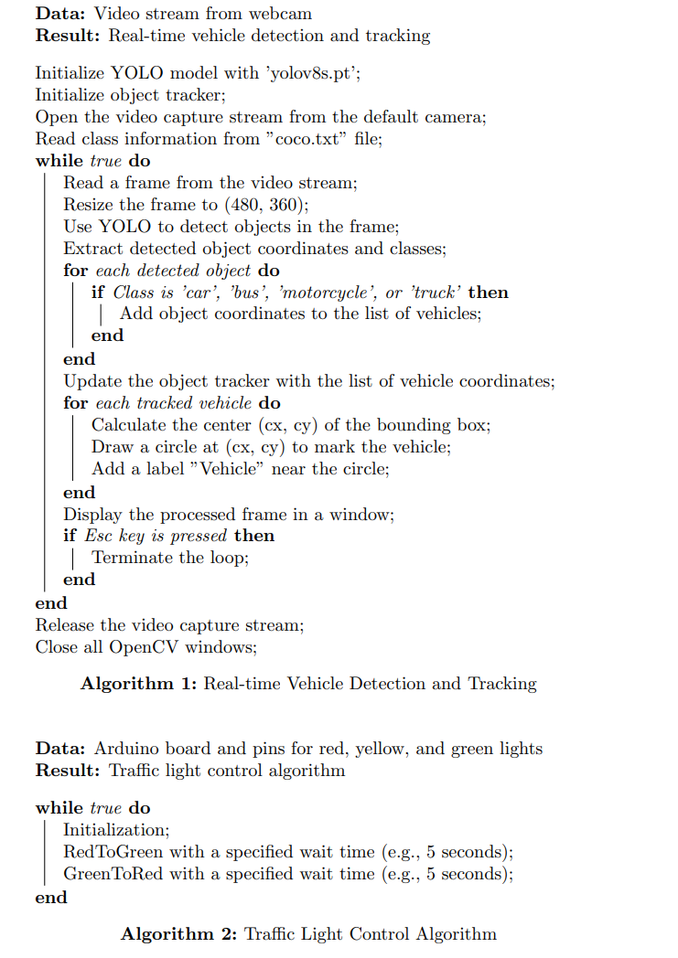

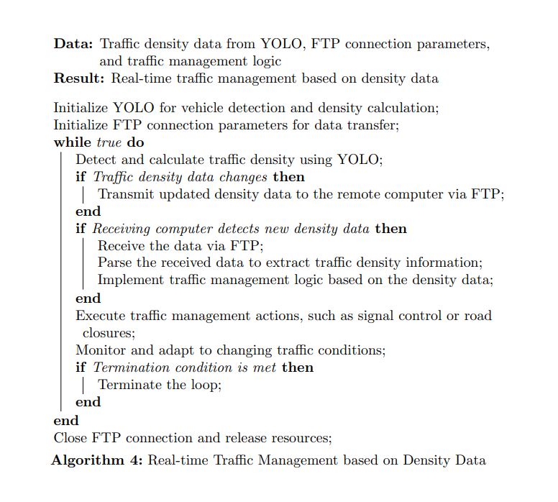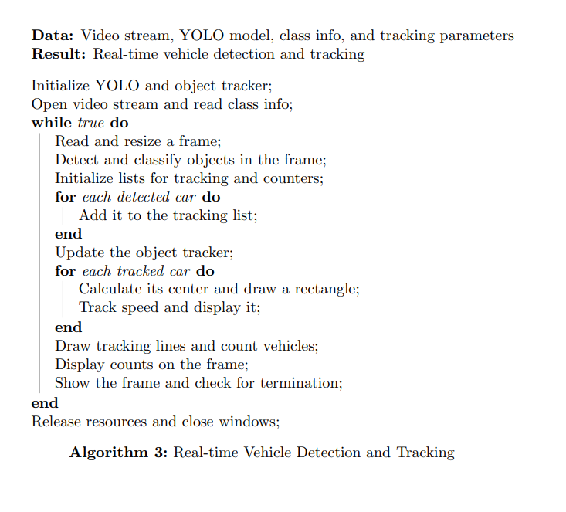

*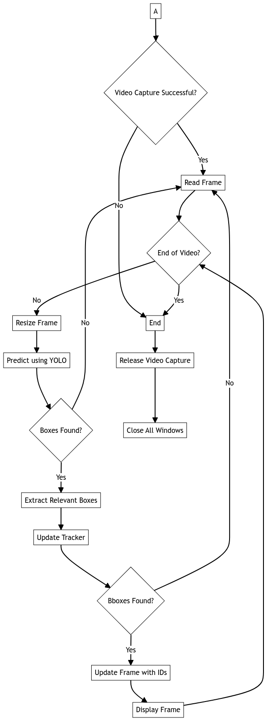****2.2 FLOW CHART***

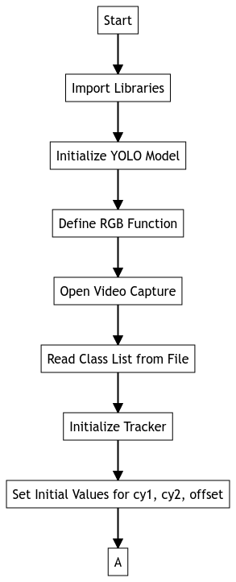

Fig (a). Flow Chart

**CHAPTER 3**

**RESULT AND DISCUSSIONS**

**CHAPTER 4**

**CONCLUSION AND LEARNING OUTCOME**

***4.2 CONCLUSION***

The proposed system sets the green signal time adaptively according to the traffic density at the signal and ensures that the direction with more traffic is allotted a green signal for a longer duration of time as compared to the direction with lesser traffic. This will lower the unwanted delays, and delays, and reduce congestion and waiting time which in turn will reduce the fuel consumption and pollution.

The new system is expected to shows much improvement over the current system in terms of the number of vehicles crossing the intersection, which is a significant improvement. This system can thus be integrated with the CCTV cameras in major cities in order to facilitate better management of traffic.

The solutions explored in the project span a wide spectrum, from short-term interventions like optimizing traffic signals timings to long-term strategies like promoting sustainable transportation modes and urban planning revisions.

The project has significant impacts on traffic congestion, ranging from increased travel times and decreased productivity to heightened pollution levels and compromised public safety.

***4.2 FUTURE ENHANCEMENTS***

While the current implementation of the traffic management system has ability to optimizing traffic flow, there are several further improvement and expansion

1. Testing on Raspberry Pi: Extending the practical application of the traffic management system, it is essential to test and optimize its performance on hardware like Raspberry Pi.
2. Improved Nighttime Accuracy with Thermal/IR Cameras: Enhancing the system's performance during nighttime or low-visibility conditions is critical. Integrating thermal or infrared (IR) cameras can provide better recognition of vehicles and pedestrians in the dark.
3. Data Encryption for Network Security: As data communication is integral to the system's functionality, implementing strong data encryption protocols is vital. Ensure that all data transmitted over the network is encrypted
4. Port Scanning for Network Discovery: To enhance the system's network capabilities, consider implementing port scanning functionality. This feature allows the system to actively discover and identify available ports on the network.
5. Expansion to Multiple Junctions: Scaling the system's deployment to cover additional junctions and intersections is a logical step for urban traffic management. Expanding the system's coverage to multiple junctions (5, 6, or more)
6. Mutual Execution: To enhance the system's robustness and reliability, consider implementing mutual execution with a tool like Siphomore. This would ensure that there is no conflict during writing files on network.

***4.3 LEARNING OUTCOMES***

* Environmental Awareness: Recognize the role traffic management plays in reducing emissions and promoting sustainable transportation practices.
* Evaluation and Analysis: Develop skills to evaluate the effectiveness of traffic light strategies by analyzing data and making evidence-based decisions.
* Traffic Management Skill: Develop a strong understanding of traffic management principles, including signal timing, intersection design, and traffic flow dynamics.
* Future Relevance: Gain knowledge and skills that are applicable in a rapidly urbanizing world where traffic management solutions are of increasing importance.
* Using AI Tools Efficiently: We believe that future is AI so we didn’t hesitated to use tool like Copilot for improving our coding skill, ChatGPT for proof reading and generating certain parts of this report, Google Bard and Mermaid.js to create images. And hence we gain a lot of knowledge how to use AI Tools for a faster efficient and streamline workflow
* Overall, participation in this project provides a well-rounded learning experience that encompasses technical skills, problem-solving abilities, teamwork, and a broader understanding of urban transportation challenges and solutions.
* Engaging in a project focused on solutions for traffic congestion using traffic lights can result in several valuable learning outcomes.

**REFERENCES**

[1] L. Rajendran , "Real-Time Adaptive Traffic Control System For Smart Cities," International Conference on Computer Communication and Informatics (ICCCI) (IEEE), pp. 1-6, doi: 10.1109/ICCCI50826.2021.9402597, March 2021.

[2] Sharon, G. Alleviating Road Traffic Congestion with Artificial Intelligence. In IJCAI (pp. 4965-4969), June 2021.

[3] Arnott, R., & Small, K. The economics of traffic congestion. American Scientist, 82(5), 446-455. 1994.

[4] Mihir Gandhi. *Smart Control of Traffic Light System using Artificial Intelligence* [Video]. YouTube. https://youtu.be/OssY5pzOyo0. May 2020